Facilitator Guide – Reablement Foundations: building Blocks for Better Living
Session 2 – The What and Why of Reablement
Slide | Slide image | Notes
1 | 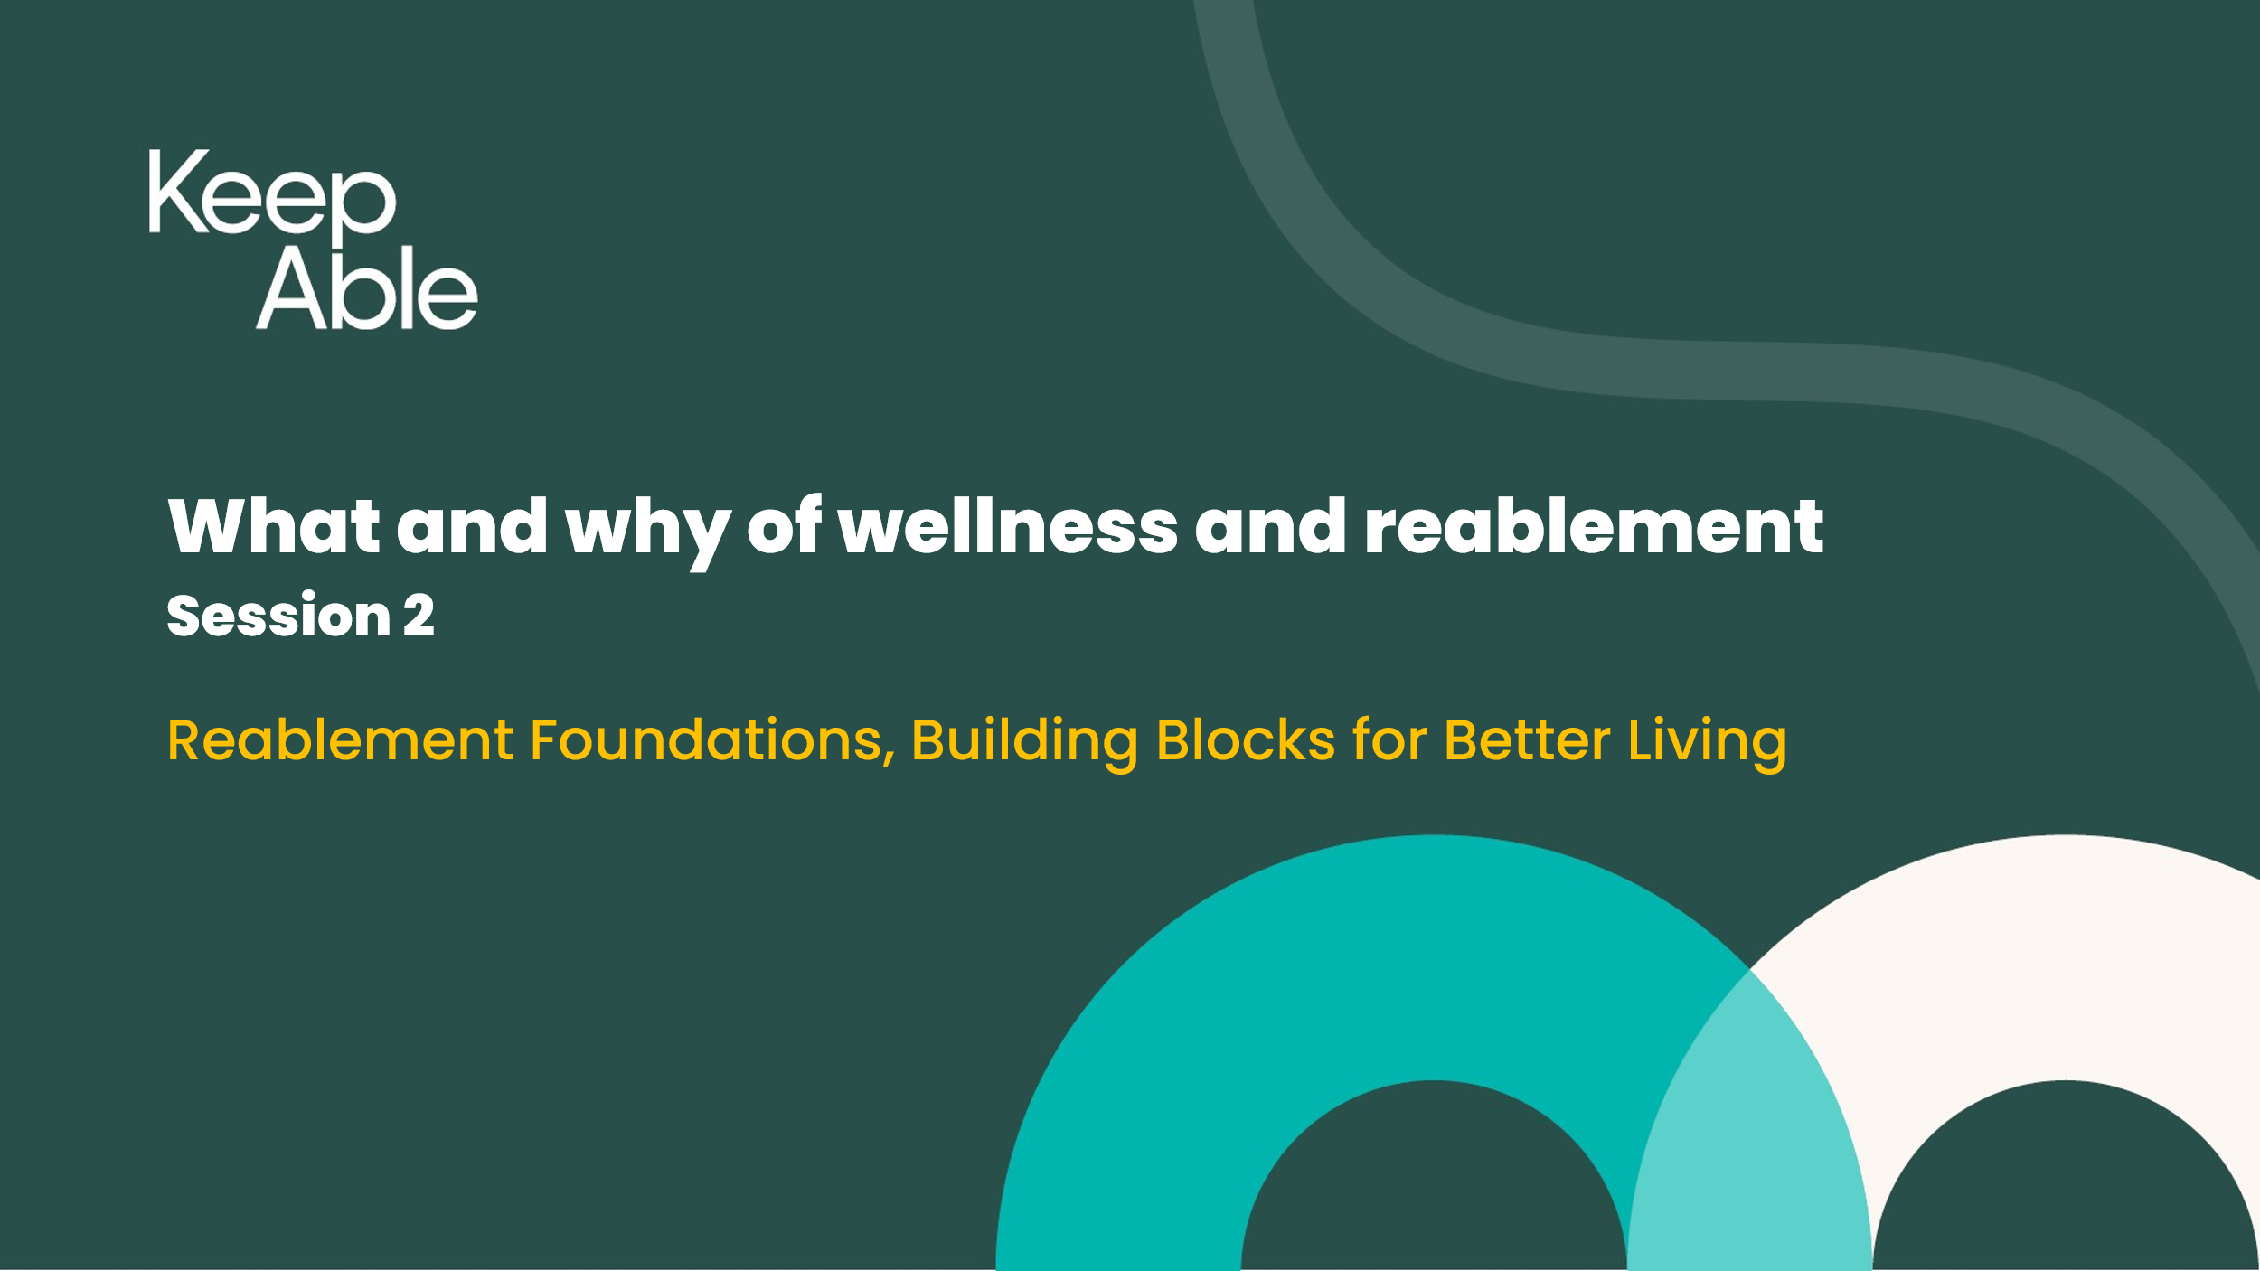 | Welcome  Note that this session follows session 1 – Reablement from Human Rights perspective  This session on understanding reablement and why it is vital in your work
2 |  | Insert your Acknowledgement of Country
3 | 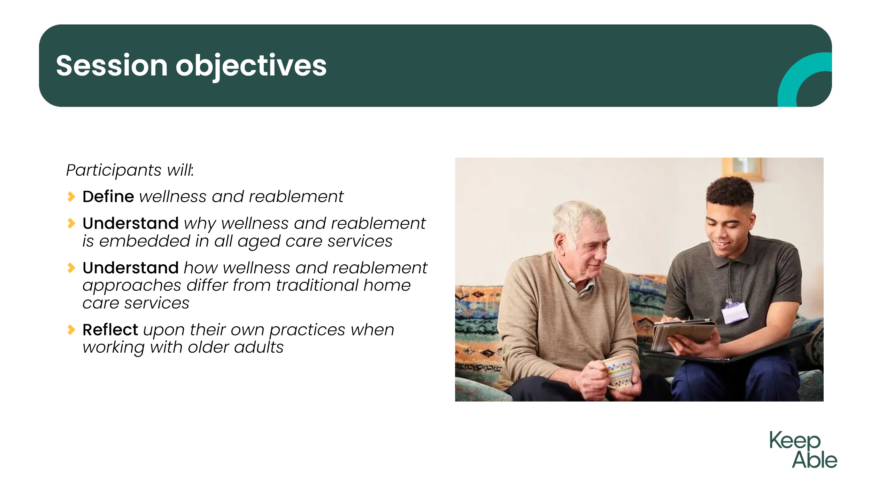 | Read through 4 points of the key objectives  on this slide
4 | 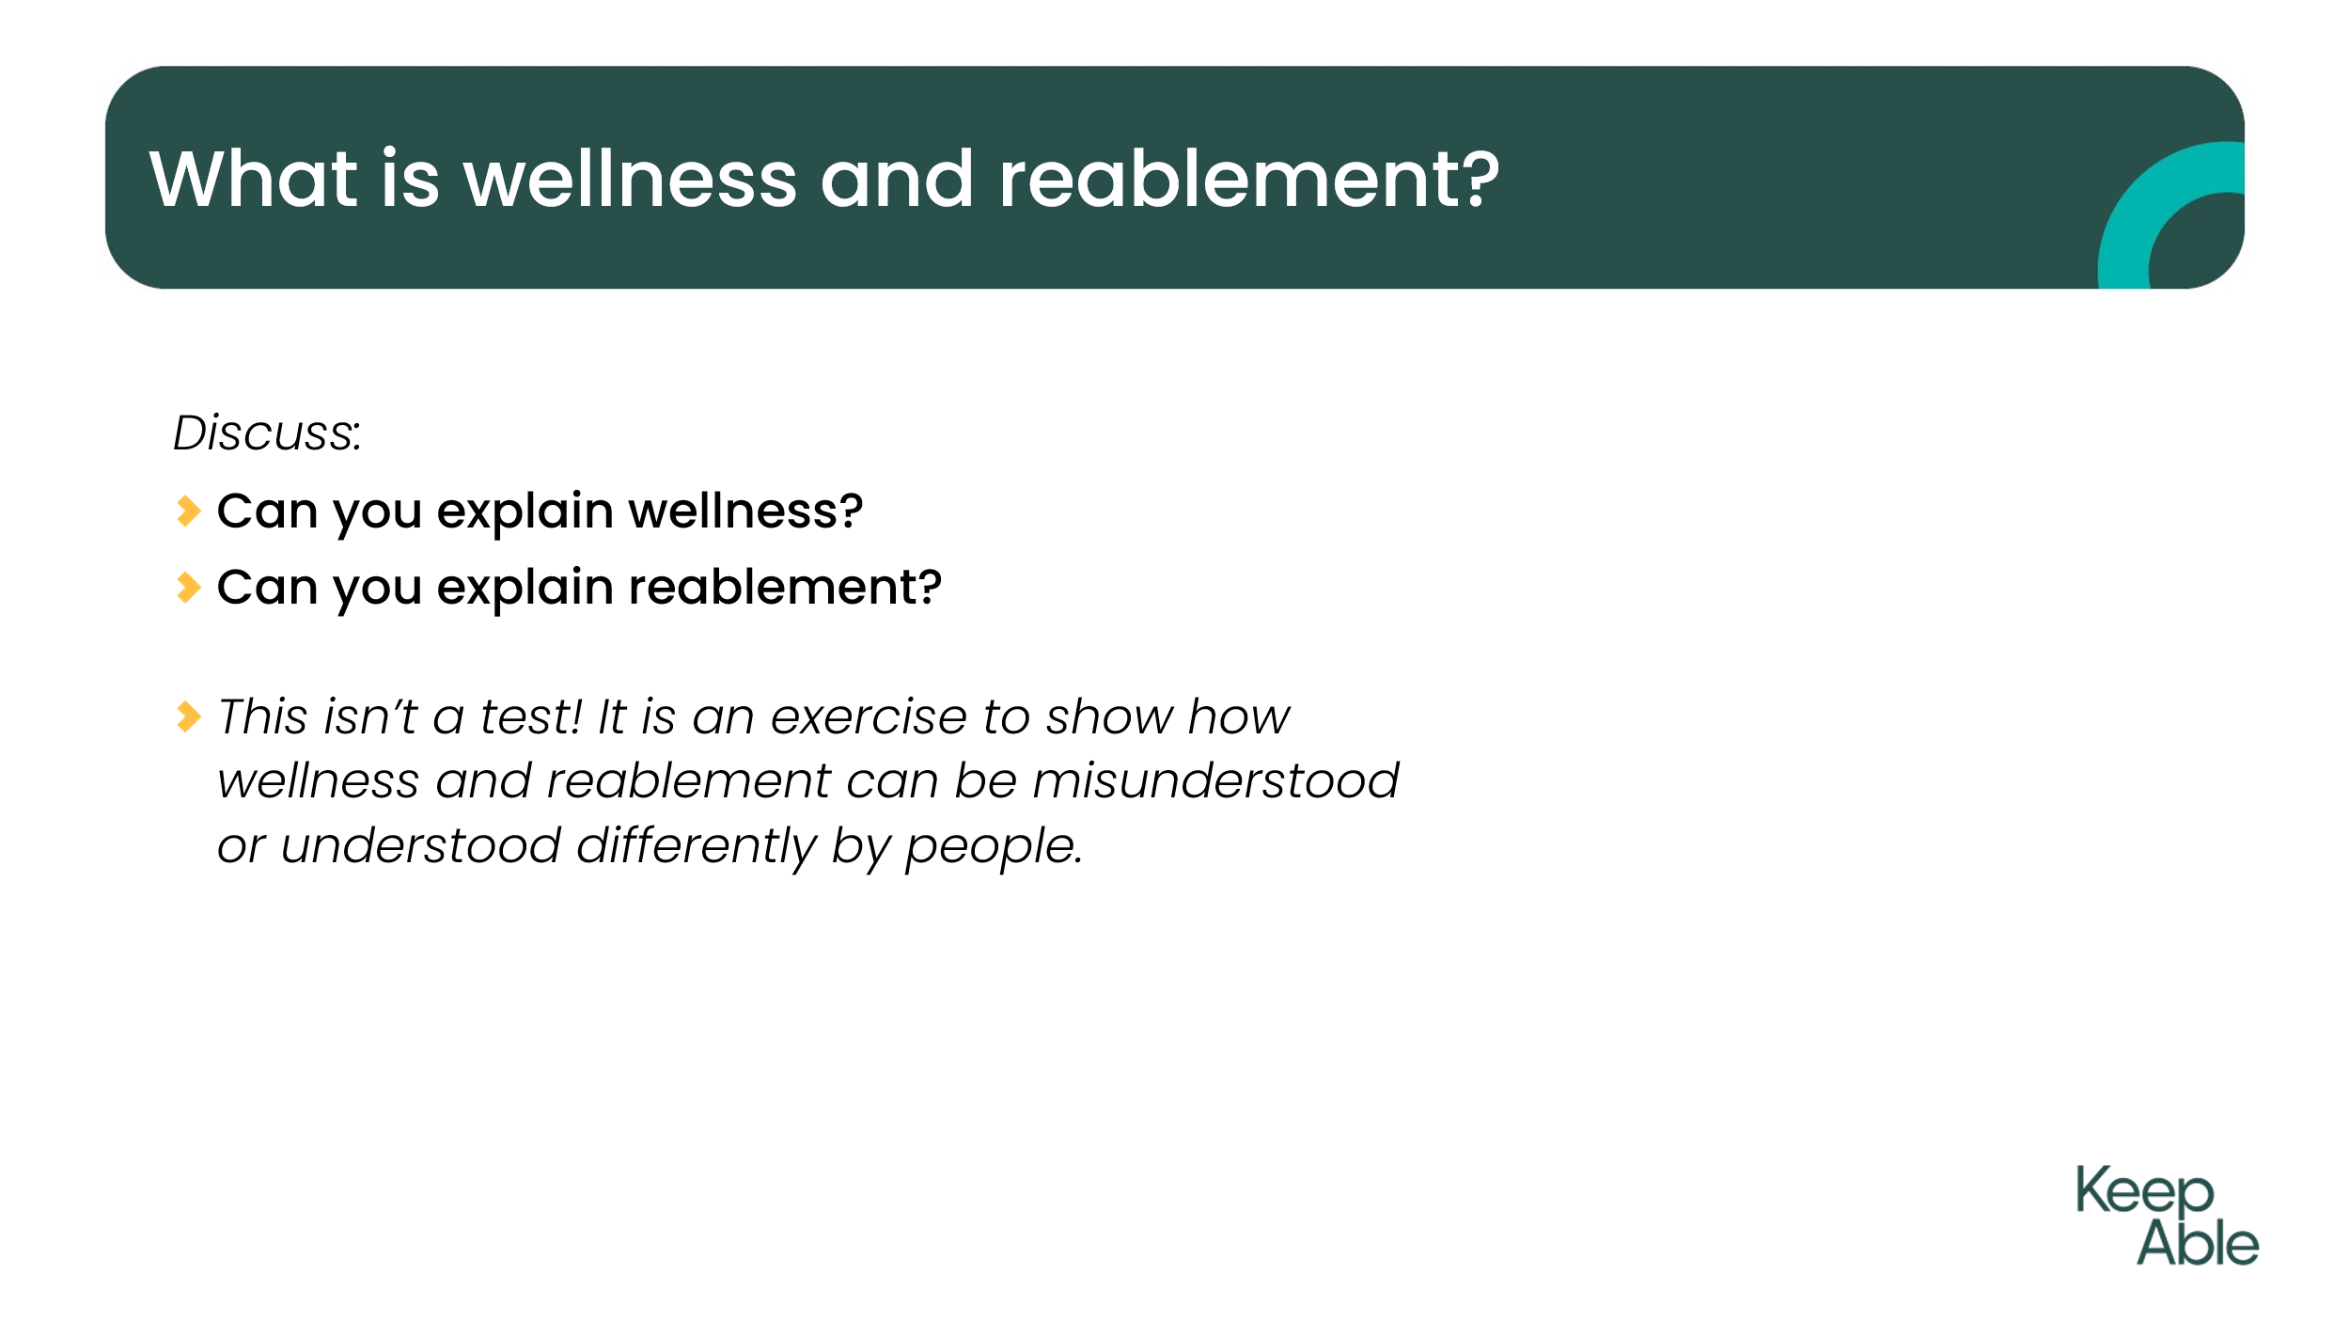 | Wellness and reablement have similar aims around supporting people to enjoy a good quality of life and be as independent as possible. However, the difference between wellness and reablement can be hard to understand. Pose questions to the group.
5 | 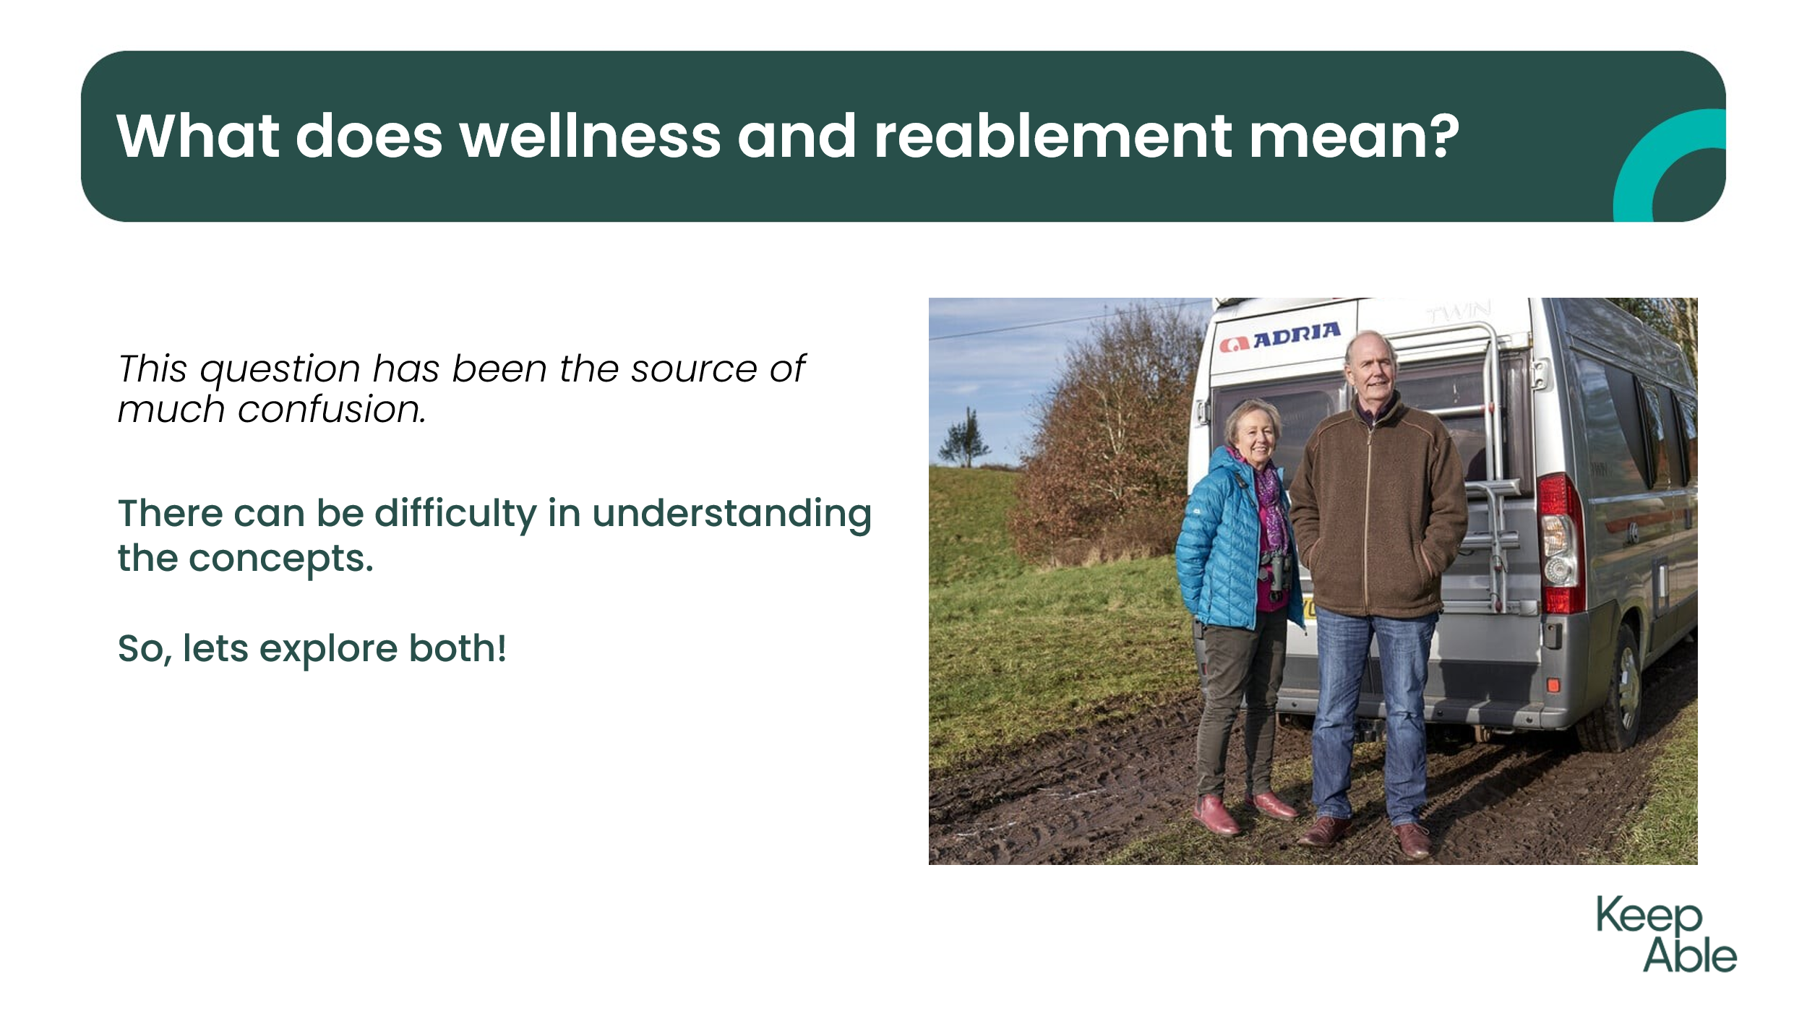 | Likely a variety of responses to the 2 questions.  Not surprising or incorrect.  Now we will look at how they differ.
6 | 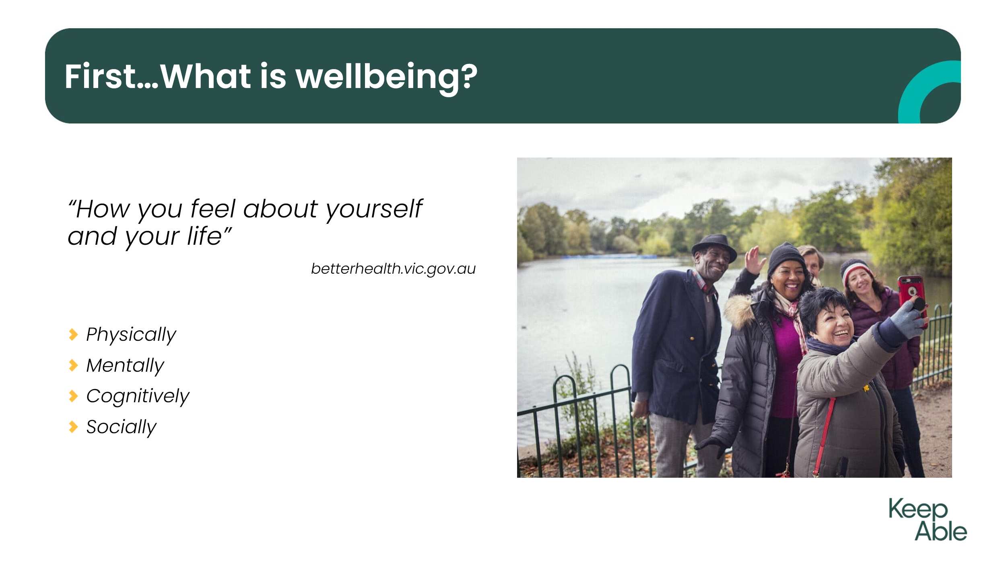 | Before we explore “wellness” as an approach it helps to understand the concept of “wellbeing”.  Wellbeing is how we feel when we are thriving and feeling good about life.  Being happy is definitely a part of wellbeing, however it is not the whole picture.
7 | 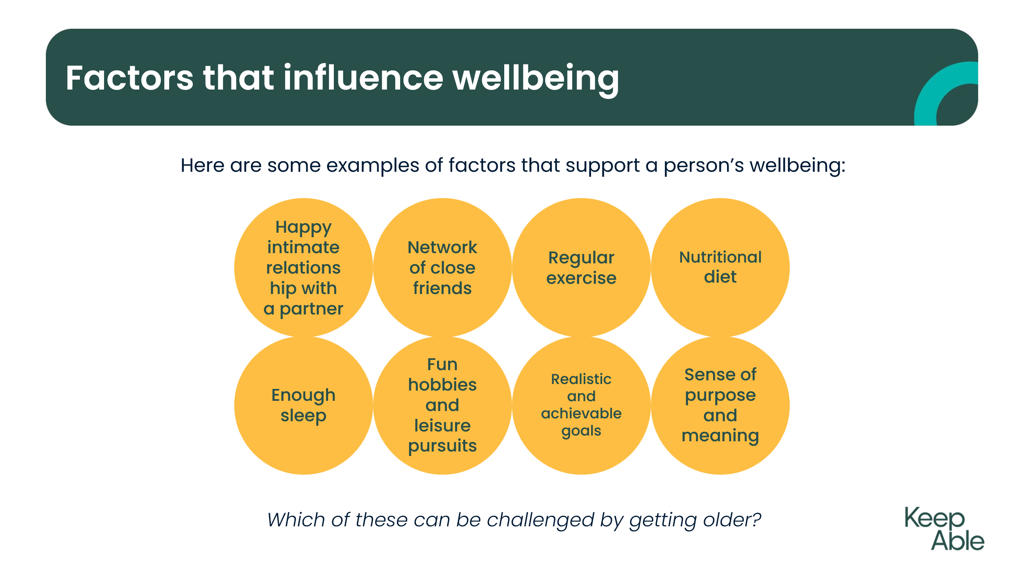 | Here are some examples of the factors that can support a persons’ wellbeing.  You may wish to pause at this point to ask the group how many of these examples can be challenged by getting older?
8 | 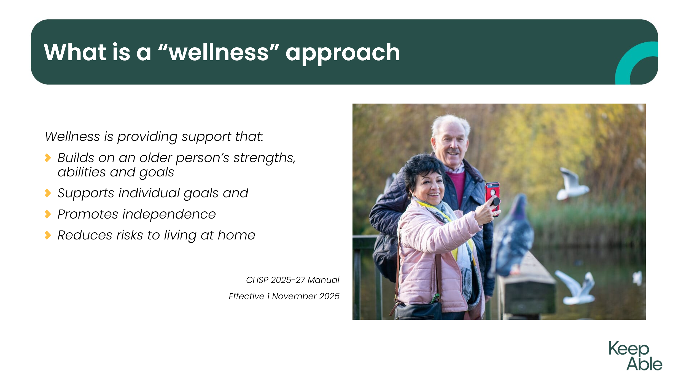 | When using wellness it needs to focus on empowering older adults to achieve their independence. The important message is doing things “with” your client and not “for” them wherever possible.
9 | 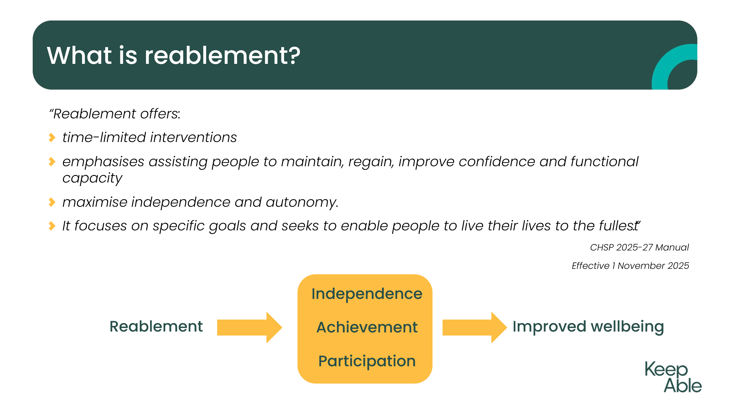 | Here is definition from the CHSP Manual.  Reablement offers – time-limited interventions, it’s about assisting them to maintain, regain or improve confidence and capacity, is focused on the persons goals for independence and what is important to them.
10 | 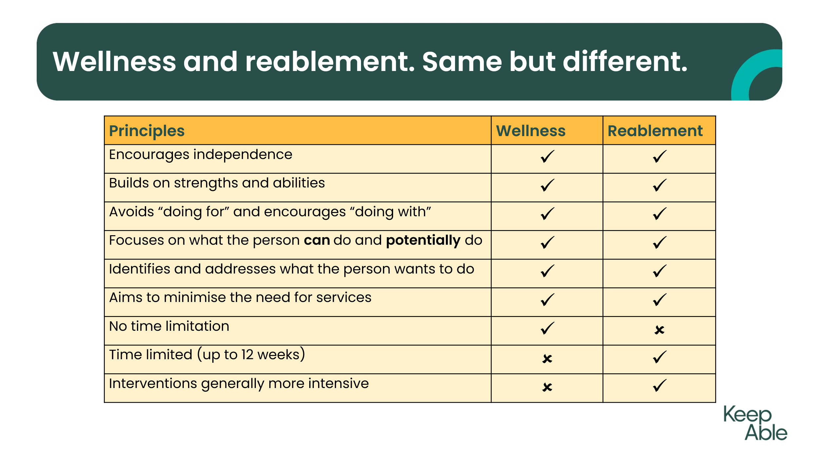 | Reablement has all the positive attributes on the list you can see with the only difference being the promotion of time-limited interventions – this is to ensure achievement of goals can be effective and achievable in a timely manner for the person.
11 | 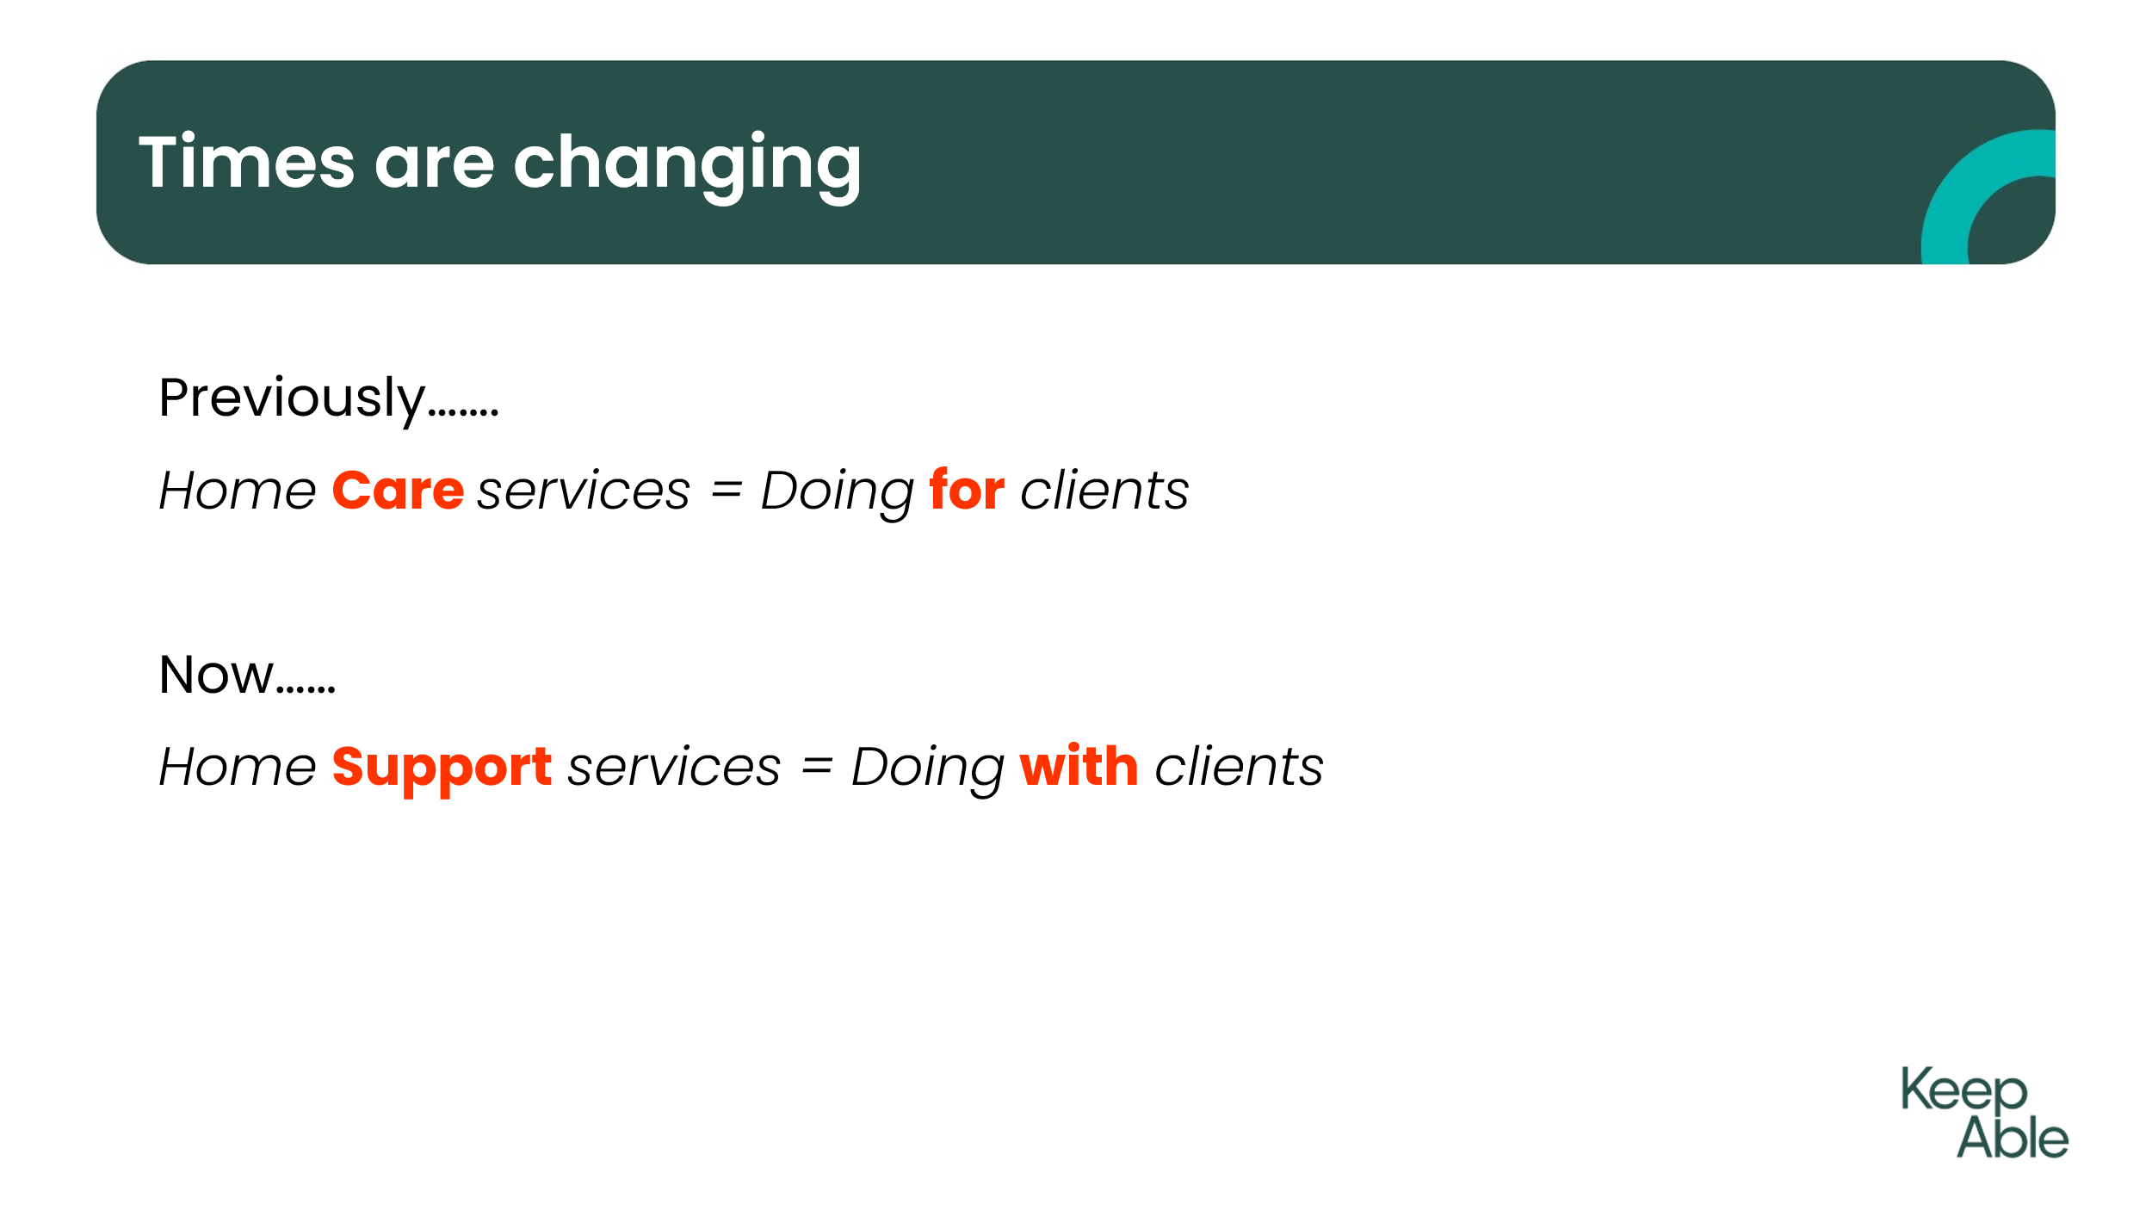 | Been a large shift in the hands-on approach of stepping in and doing things for people. Now expected to assist people to explore ways to maximise independence.
12 | 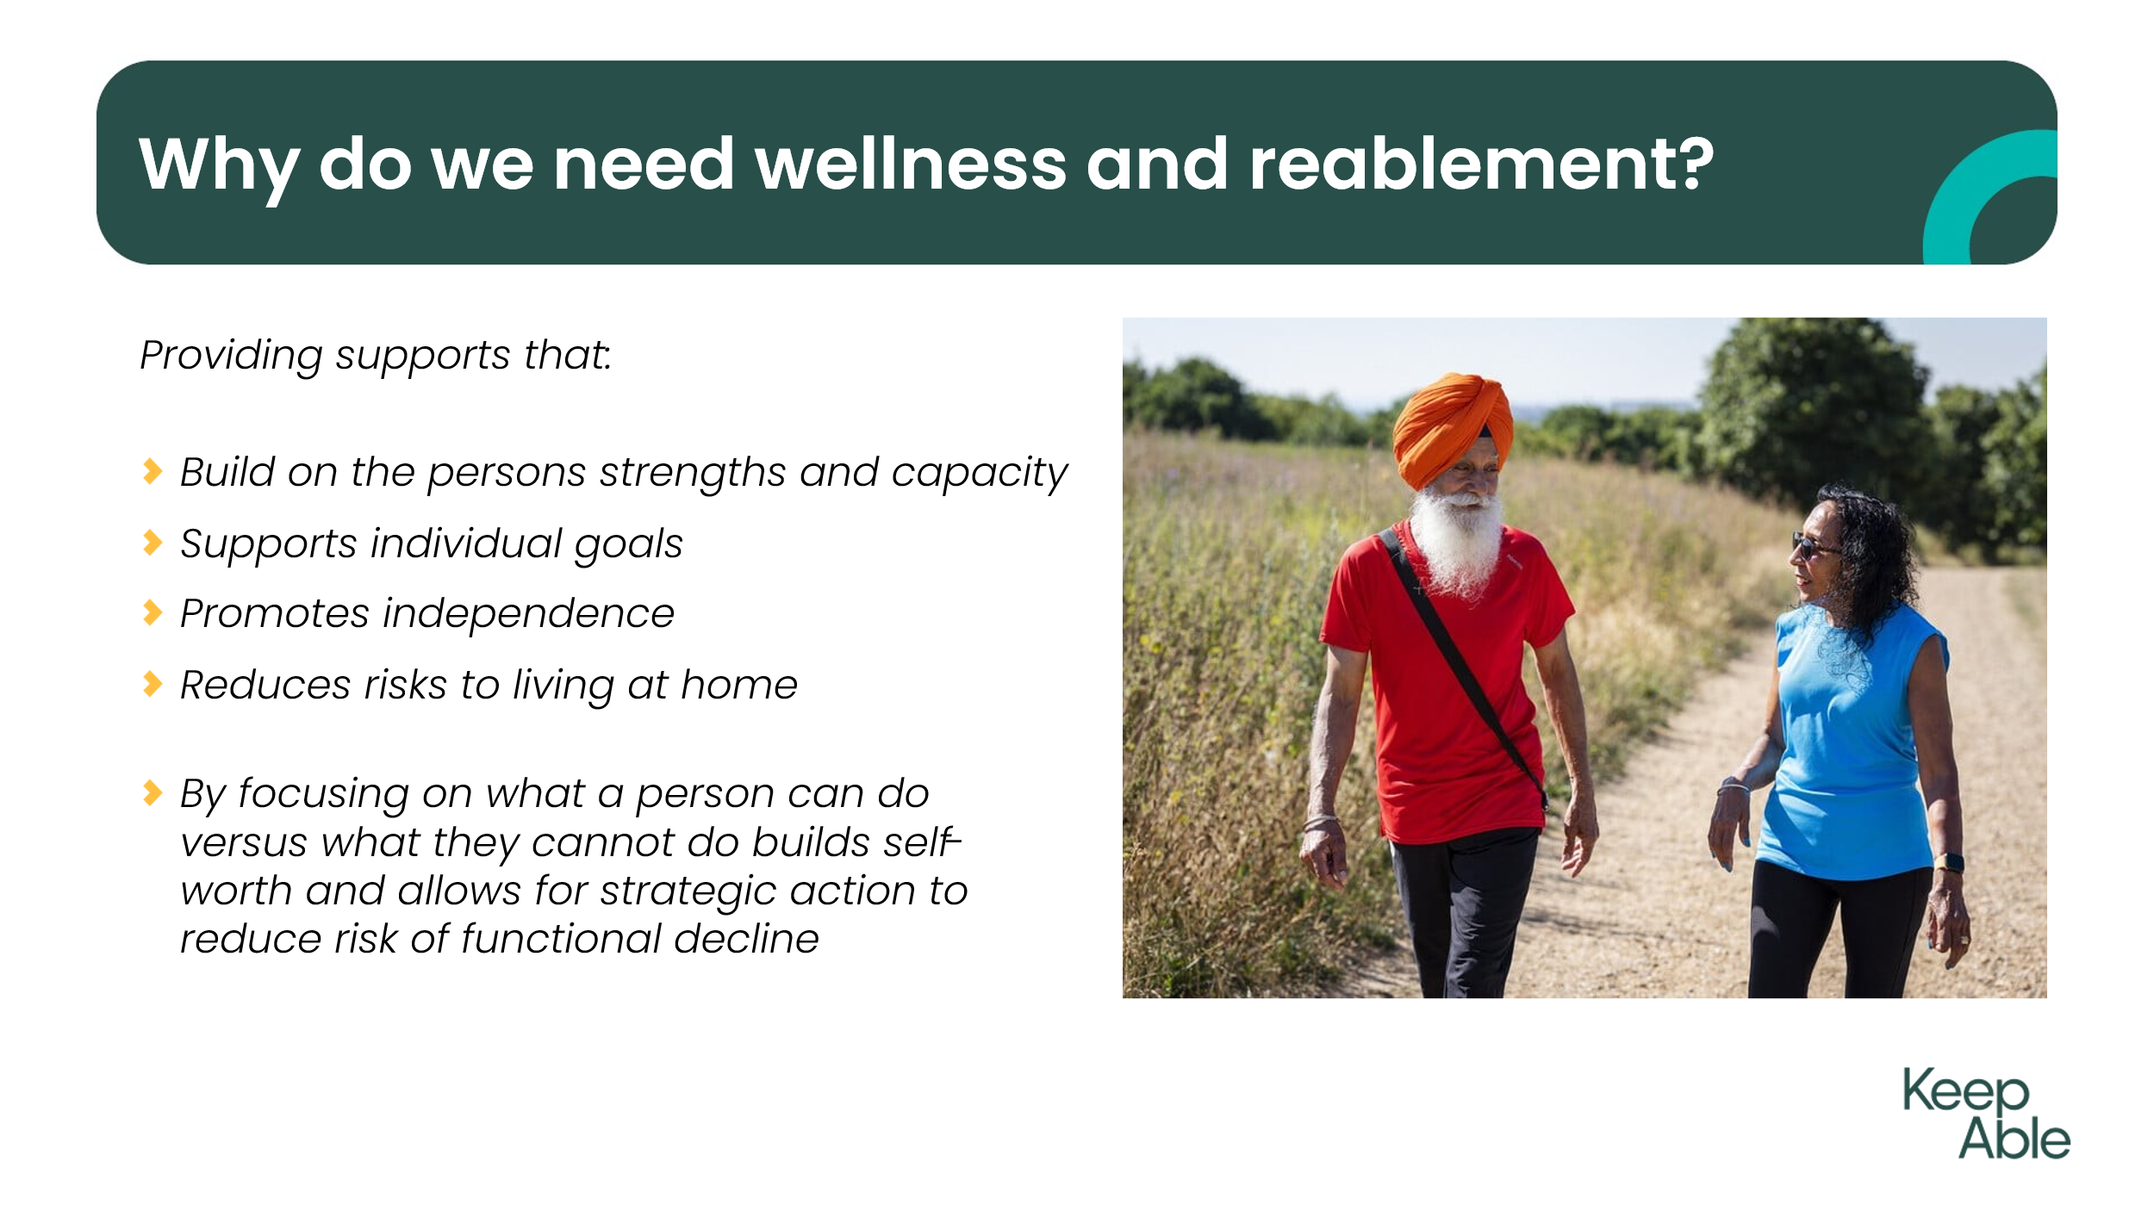 | Being able to deliver services to clients in a way that builds on their capacity, supports them with their personal goals, promotes independence and reduces risks are all methods to improve their quality of life and reduce need for long-term care.
13 | 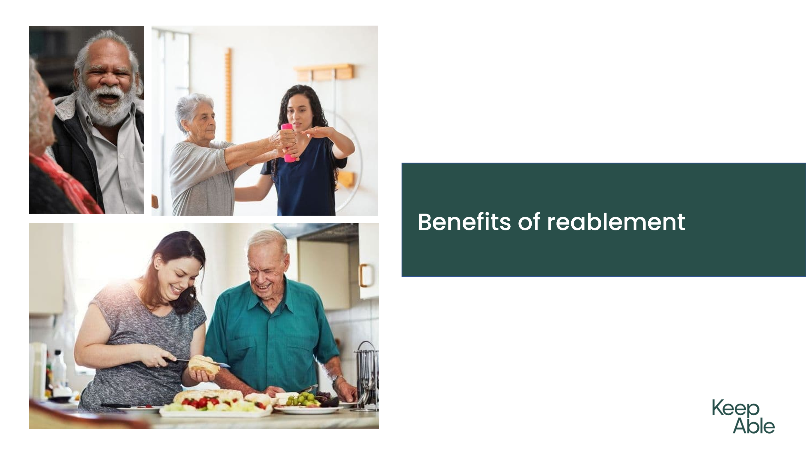 | Evidence suggests there are also large benefits for service provider organisations, families and carers, and the broader community.  Job satisfaction, better use of resources and time, short-term equals more clients etc
14 | 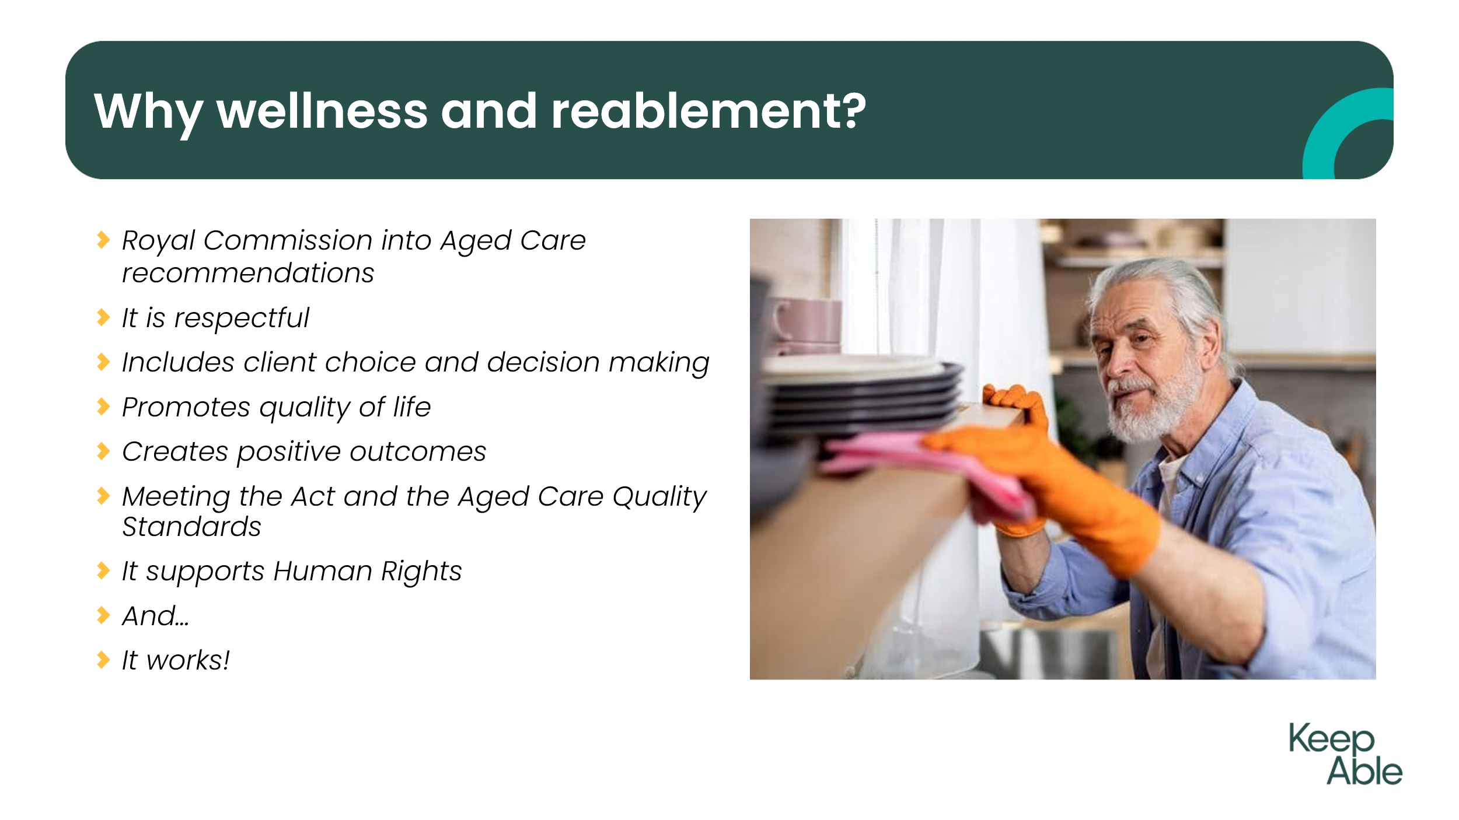 | Wrap up on why W&R should be used
15 | 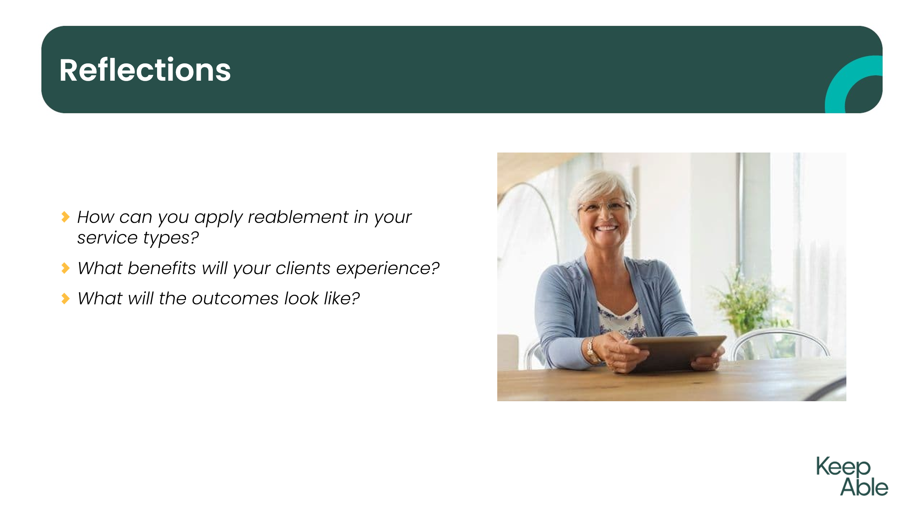 | Opportunity to share reflections on experience and share thoughts on what has been learnt
16 | 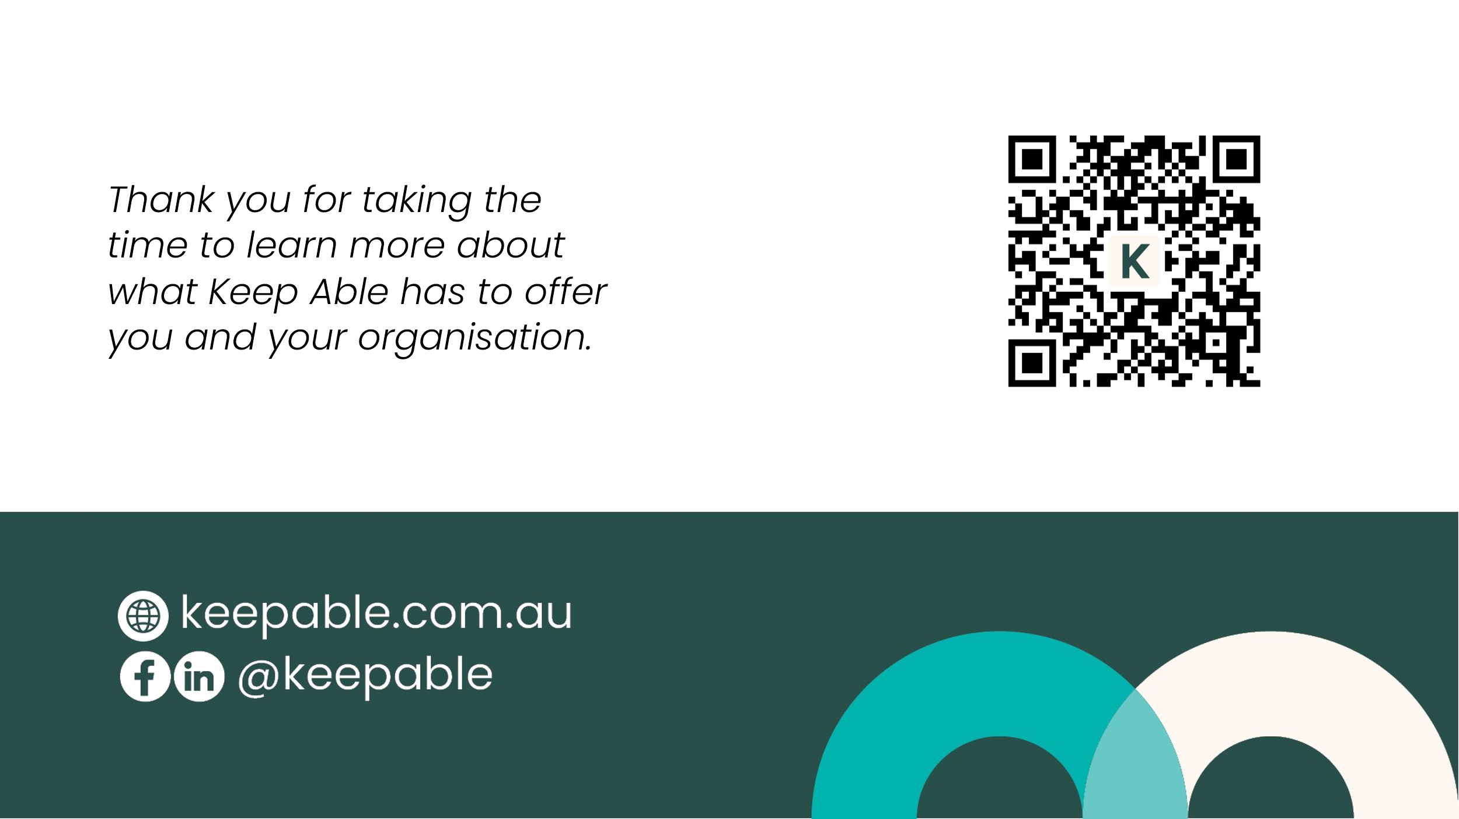 | Thank you for participating

